Crawlers

Glue Database

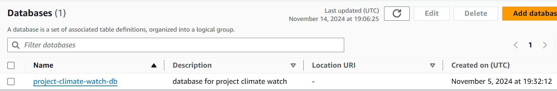

Glue Tables

Schema

Glue to RDB Connection

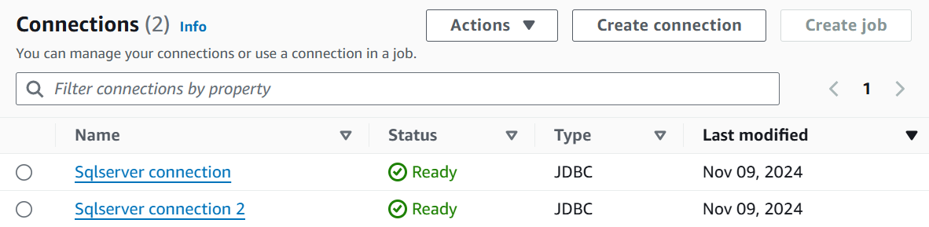

Glue Databrew Datasets

Databrew Project – Data Preparation

Databrew Project Recipe

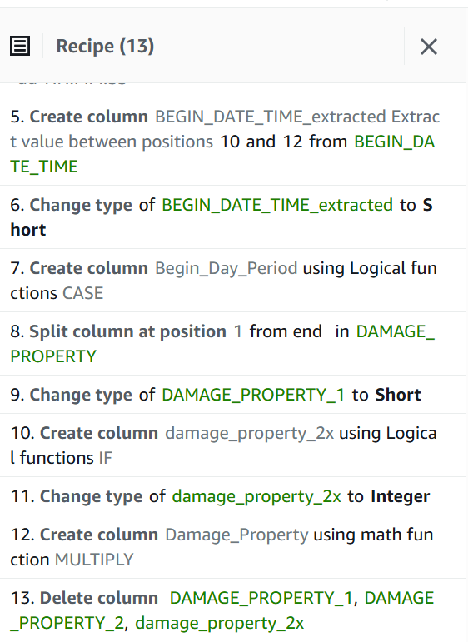

Databrew Job Run

|  |
| --- |
| A1:A52, |
| B1:B52, |
| C1:C52, |
| D1:D52, |
| E1:E52, |
| F1:F52, |
| G1:G52, |
| H1:H52, |
| I1:I52, |
| J1:J52, |
| K1:K52, |
| L1:L52, |
| M1:M52, |
| N1:N52, |
| O1:O52, |
| P1:P52, |
| Q1:Q52, |
| R1:R52, |
| S1:S52, |
| T1:T52, |
| U1:U52, |
| V1:V52, |
| W1:W52, |
| X1:X52, |
| Y1:Y52, |
| Z1:Z52, |
| AA1:AA52, |
| AB1:AB52, |
| AC1:AC52, |
| AD1:AD52, |
| AE1:AE52, |
| AF1:AF52, |
| AG1:AG52, |
| AH1:AH52, |
| AI1:AI52, |
| AJ1:AJ52, |
| AK1:AK52, |
| AL1:AL52, |
| AM1:AM52, |
| AN1:AN52, |
| AO1:AO52, |
| AP1:AP52, |
| AQ1:AQ52, |
| AR1:AR52, |
| AS1:AS52, |
| AT1:AT52, |
| AU1:AU52, |
| AV1:AV52, |
| AW1:AW52, |
| AX1:AX52, |
| AY1:AY52, |
| AZ1:AZ52, |
| BA1:BA52, |
| BB1:BB52, |
| BC1:BC52, |
| BD1:BD52, |